BEM 150: Check-in 3

Advith Chelikani, Nick Haliday, Logan Cross

**Overview**: In our project we have decided to focus on investigating overutilization in the United States. Overutilization is the over-prescription of medical services of any kind. We have decided to focus on a set of services/procedures that are often performed on patients unnecessarily. We are then working to identify instances of these procedures through examining medicare data sets and identifying regions with overutilization. Using the Factual data we are examining prevalence of cases of use of a specific procedure with respect to the number of doctors in that locality that perform that procedure. Also, by using data from the Dartmouth Atlas, we are able to identify a multitude of variables that explain regional variance in overutilization and overuse of unbeneficial procedures and services.

**Preliminary Analysis**:

**Regressions with cost per Medicare enrollee**

First we ran multiple linear regressions with cost per beneficiary within a region (HRR) as the dependent variable, with multiple iterations of different types of explanatory variables. The total Medicare costs per enrollee variable was adjusted for age, sex, and race within the region as these variables account for a large amount of well-known variance in healthcare costs (ie. older people cost more).

1. Use explanatory variables corresponding to the number of interactions Medicare enrollees have with the medical system

|  |  |  |  |  |  |
| --- | --- | --- | --- | --- | --- |
| Intercept | Average number of contact days with the health care system per beneficiary | Percent of beneficiaries whose predominant provider was a primary care physician | Average number of unique clinicians seen per beneficiary | Percent of beneficiaries having an annual wellness visit | Average number of inpatient days per beneficiary |
| 6821.177*** | 490.827 *** | -42.332 *** | -1572.778*** | 16.100 . | 413.836 *** |

Signif. codes: 0 ‘***’ 0.001 ‘**’ 0.01 ‘*’ 0.05 ‘.’ 0.1 ‘ ’ 1

Takeaways: As expected, Medicare costs are highly associated with the number of contact days with the health care system and inpatient days. However, Medicare costs are negatively associated with reliance on a primary care physician as the major provider. Also, costs go down as a beneficiary sees more unique clinicians.

1. Use unnecessary or controversial operations and treatments as explanatory variables. For example, there is a consensus that prostate cancer screening should not occur for men over the age of 75 as the benefits do not outweigh the harms (Ann Intern Med, 2008;149(3):185-91.)

|  |  |  |  |  |  |
| --- | --- | --- | --- | --- | --- |
| Intercept | Percent of male beneficiaries age 75 and over having screening PSA | Percent of female beneficiaries age 75 and over having screening mammogram | Percent of decedents enrolled in hospice in the last 3 days of life | Percent of beneficiaries with dementia receiving a feeding tube during the last 6 months of life | Average number of ICU days per decedent during the last 6 months of life |
| 8616.766  *** | 128.271  *** | -162.307  *** | -18.622  ** | 929.675  *** | 31.240  * |

Signif. codes: 0 ‘***’ 0.001 ‘**’ 0.01 ‘*’ 0.05 ‘.’ 0.1 ‘ ’ 1

Takeaways:

-In accordance with the medical consensus, prostate exams after the age of 75 do not have a beneficial effect from a cost perspective. The percentage of beneficiaries over 75 having a screening PSA is positively associated with overutilization and excessive spending within a region

-For mammograms, there is less of a medical consensus, by screening for women over the age of 75 is under debate. There is insufficient evidence that the costs outweigh the harms from a monetary and a health perspective (JAMA Intern Med, 2014;174(3):448-54.). In this analysis, it seems that screening mammograms may provide a financial benefit, as it is negatively associated with spending within a region

-Hospice care at the end of life is controversial as it may not reflect a patient’s preferences and the quality of care may not be optimal. However, there is not a strong significant effect in this analysis

-Clinical evidence suggests that feeding tubes for dementia patients does not prolong life and can even cause further complications. This procedure is such a no-go that is featured in the Choosing Wisely Initiative of operations that every doctor should avoid to limit overutilization. Given the very large significant correlation we found with spending, regional variation of this variable may be an interesting avenue for further analysis

-Surprisingly, the average number of ICU days at the end of life is not significantly associated with regional variations in overutilization

**Regressions with specific procedures**

To uncover explanatory variables that have a contextual effect on overutilization, we used specific controversial or unnecessary treatments as dependent variables in multiple regression. Explanatory variables that can account for the regional variance for these procedures will give us a better idea of why they occur more often in some areas over others.

1. **Bariatric surgery:** bariatric surgery is a treatment for obesity that involves reducing the size of the stomach through an invasive procedure. Although bariatric surgery is often effective for reducing obesity, it can come with serious complications. It does not fix or uncover the ultimate behavioral problem and thus should be applied as a last resort. We hypothesized that the prevalence of this surgery would be negatively correlated with increased visitations to a primary care physician who would encourage exercise and health eating as a treatment for obesity.

**Correlations between 1. Bariatric surgeries per 100,000 people 2. Percentage of the population that has diabetes 3. Percentage of the population that is obese and 4. Percentage of the population that visits a primary care physician at least once a year**

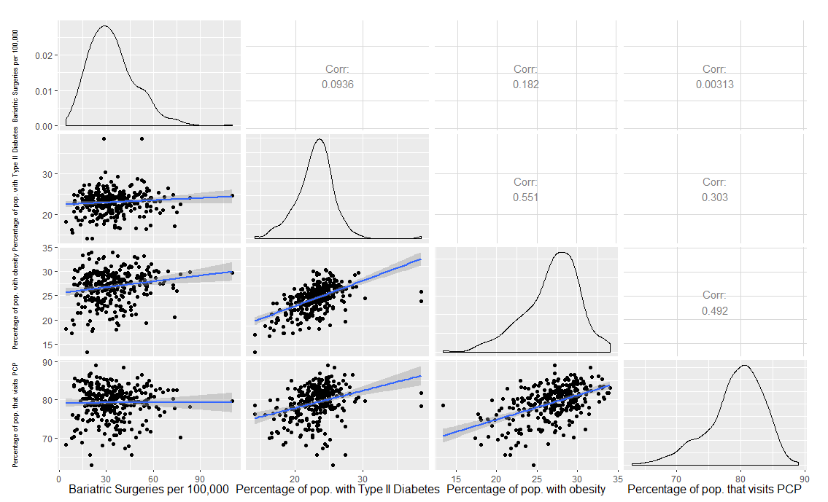

Takeaways: The number of bariatric surgeries is not significantly correlated with any of these variables independently. This analysis is hampered by the fact that these three variables are all correlated with each other. Thus, a multivariate regression analysis is an appropriate next step.

|  |  |  |  |
| --- | --- | --- | --- |
| Intercept | Percentage of population with Type II Diabetes | Percentage of population with Obesity | Percentage of population that has visited a PCP at least once in the past year |
| 36.48684  * | -0.02648 | 1.08600  ** | -0.39401  . |

Signif. codes: 0 ‘***’ 0.001 ‘**’ 0.01 ‘*’ 0.05 ‘.’ 0.1 ‘ ’ 1

Takeaways: When all three of these variables are introduced into the model, their relationships with bariatric surgery amounts are easier to see. As expected, more obesity is associated with more surgery. And as suggested in the hypothesis, visiting a primary care physician is negatively associated with more surgery (although only modestly).

1. **Feeding tube for dementia patients:** as previously discussed, this procedure provides no positive benefit for a patient’s outcome and may even have a negative effect. It should be avoided by all doctors as recommended in the Choosing Wisely Initiative. We wanted to uncover what variables could explain regional variance in this procedure.

|  |  |  |  |  |  |
| --- | --- | --- | --- | --- | --- |
| Intercept | Average number of contact days with the health care system per beneficiary with dementia | Average number of inpatient days per beneficiary with dementia | Average number of unique clinicians seen per beneficiary with dementia | Percent of beneficiaries with dementia whose predominant provider was a primary care physician | Percent of beneficiaries with dementia filling prescriptions for high-risk medications |
| -2.04824 | 0.45580  *** | 0.04927 | -2.02736  *** | -0.02362 | 0.11882  *** |

Signif. codes: 0 ‘***’ 0.001 ‘**’ 0.01 ‘*’ 0.05 ‘.’ 0.1 ‘ ’ 1

Takeaways: Interestingly, the average number of contact days and the percent filling prescriptions is positively associated with the percentage of patients receiving a feeding tube with advanced stage dementia. This result could mean that the worse a patient is, the more likely they are to receive a feeding tube as they may be unable to eat with their own will. However it should be noted, even in this case, a feeding tube is not recommended or beneficial. Also, the percentage of patients receiving a feeding tube is negatively associated with the number of unique clinicians seen. A speculative interpretation here is that as a patient sees more clinicians for different opinions, there is an increased likelihood that they will encounter a doctor who knows how unbeneficial a feeding tube is for dementia patients near the end of life.

**Presentation:** <https://goo.gl/SX4khX>